# 2. ReactJS - HOL

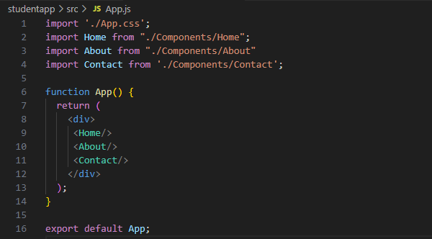

App.js

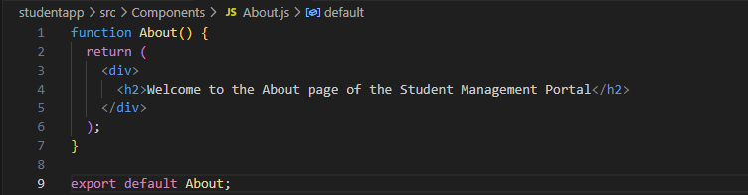

About.js

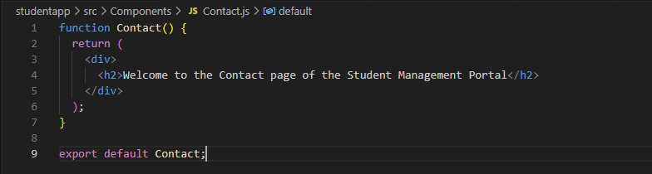

Contact.js

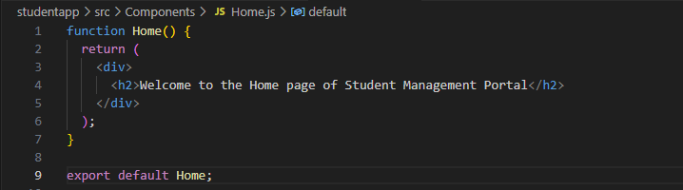

Home.js

Output:

